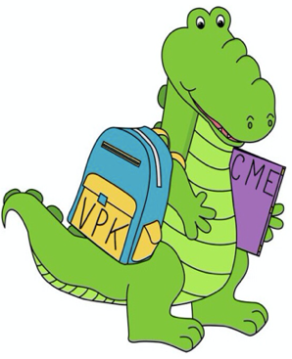
Pre-K (VPK) Supply List
Christina M. Eve Elementary

- Small back pack (no wheels, big enough to hold a folder and blanket)
- 1 primary note book- (no spirals, with blank space on top for picture)
- 1 red folder (2 pockets, heavy plastic)
- Mead Five Star makes a sturdy one.
- 2 bottles of Elmer’s liquid glue
- 1 Pack of Jumbo Elmer’s glue sticks
- 1 four-fold nap mat
- Small blanket (baby blankets work well)
- Complete change of clothes in a zip lock to keep in classroom (It may be a non-uniform outfit. Please include: pants, shirt, underwear, and socks. Please label all clothes and place in a gallon size zip lock bag)
- 1 large bottle of hand sanitizer (pump/refill)
- 1 bottle of hand soap
- 1 tissue box
- 1 pack of small Expo markers
- 1 pack of large Expo markers
- Small photo of student

Helpful
- Disinfecting spray
- Baby wipes
- Lysol wipes
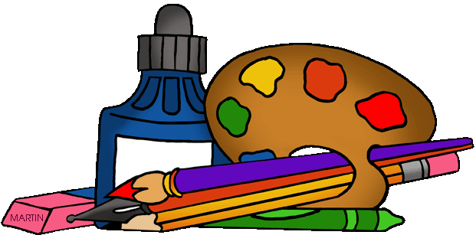
Art Materials

- Scotch tape
- Masking tape (any color)
- Crayola markers (fine line & broad line)
- Crayola coloring pencils
- Playdoh
- Cardstock (white & color)
- Plastic pony beads
- Craft sticks jumbo
- Jumbo Crayola crayons
- Hole punchers (decorative shapes)

