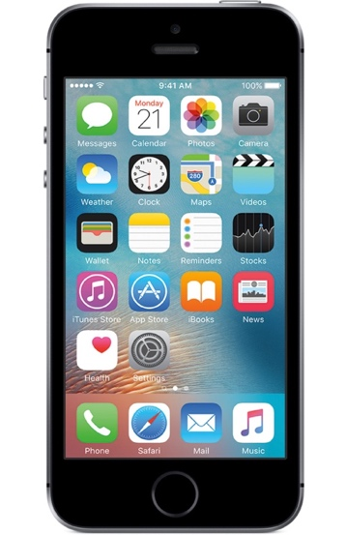

What Is Waterford Mentor?
Waterford Mentor is a companion app for Waterford Early Learning and SmartStart available in the iTunes and Google Play stores. The app allows parents or caregivers to track their student’s Waterford reading time and achievements.

How Waterford Mentor Works
Teachers provide a Mentor code to the parents or caregivers of every student in their classroom. This code allows parents to link their Waterford Mentor accounts to their student’s information. After downloading the app to their device, parents can log in, link their student’s account, and access their student’s Waterford Early Learning (grades K-2) or SmartStart (PreK) usage and achievement data.

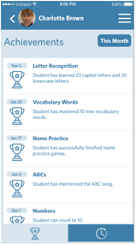
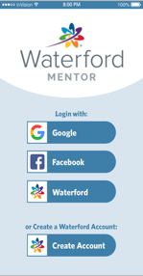
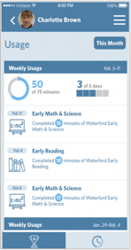
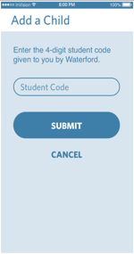
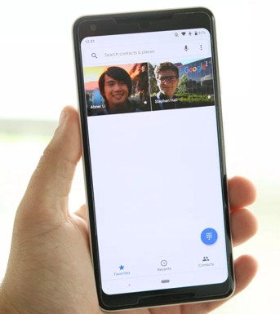

Link to a student’s information by entering the Mentor code provided by their teacher.

The achievements screen displays objectives mastered by a student over a recent time period.

Setting up and using Waterford Mentor is easy.

The usage screen shows student usage which supports their progress toward goals set by their school.

